|  |  |  |
| --- | --- | --- |
|  |  | |
| C:\Users\kperrin\Desktop\August 2016\P1020761.JPG |  | **Alexandria Arlington**  **Resource Recovery Facility**  Fiscal Year 2017  First Quarter Operations Report  **November 2016** |
| C:\Users\kperrin\Desktop\August 2016\P1020771.JPG |  |
| **Prepared by:**  **HDR Engineering, Inc.**  **5426 Bay Center Drive, Suite 400**  **Tampa, Florida 33609-3444** | C:\Users\kperrin\Desktop\August 2016\P1020786.JPG | |
|  |  | |

Table of Contents

Section No. Page No.

1.0 Purpose of Report 4

2.0 Executive Summary 4

3.0 Facility Inspection and Records Review 5

4.0 Facility Performance 9

4.1 Utility and Reagent Consumptions 23

4.2 Safety & Environmental Training 24

5.0 Facility Maintenance 25

5.1 Availability 26

5.2 Downtime Summary 28

5.3 Facility Housekeeping 29

6.0 Environmental 30

6.1 Nitrogen Oxide Emissions 30

6.2 Sulfur Dioxide Emissions 30

6.3 Carbon Monoxide Emissions 30

6.4 Opacity 31

6.5 Daily Emissions Data 31

6.6 Ash System Compliance 31

APPENDIX A FACILITY CEMS DATA 34

APPENDIX B PHOTOS 38

**Front Cover Photos**

**Top:** General Facility Photo from Across Eisenhower Avenue

**Middle:** Cooling Towers – photo from SDA Penthouse

**Bottom:** New Access Platform to Induced Draft Fans

List of Tables

Table No. Page No.

Table 1: Summary of Inspection Report Deficiencies 7

Table 2: Quarterly Performance Summaries 15

Table 3: Waste Delivery Classification 17

Table 4: Facility Utility and Reagent Consumptions 23

Table 5: Quarterly Facility Unit Availabilities 27

Table 6: Boiler Downtime – Q1FY17 28

Table 7: Turbine Generator Downtime – Q1FY17 28

Table 8: Facility Housekeeping Ratings – August 2016 29

Table 9: Comparison of Statistical Results and Regulatory Thresholds for Metal Analytes 32

Table 10: Unit #1 Monthly Summary for Reportable Emissions Data 35

Table 11: Unit #2 Monthly Summary for Reportable Emissions Data 36

Table 12: Unit #3 Monthly Summary for Reportable Emissions Data 37

List of Charts

Chart No. Page No.

Chart 1: Tons of Waste Processed 9

Chart 2: Tons of Ash Produced per Ton of Waste Processed 10

Chart 3: Ferrous Recovery Rate 11

Chart 4: Steam Production 12

Chart 5: 12-Month Rolling Steam Production 13

Chart 6: Steam Production Rate 14

Chart 7: Calculated Waste Heating Value 15

Chart 8: Cumulative Total Waste Delivery 18

Chart 9: Gross Electrical Generation 18

Chart 10: Gross Conversion Rate 19

Chart 11: Net Conversion Rate 20

Chart 12: Net Conversion Rate 20

Chart 13: Gross Turbine Generator Conversion Rate 21

Chart 14: Net Turbine Generator Conversion Rate 22

Chart 15: Ash Toxicity Characteristic Leaching Procedure (TCLP) Results 32

Chart 16: Quarterly Ash Test Results 33

List of Figures

Figure No. Page No.

Figure 1: Safety Cage on Rotary Sootblower No. 27 detached and gears exposed – New Deficiency 39

Figure 2: Underside of grating deteriorated, upper elevations of all three economizers – New Deficiency 39

Figure 3: Hole in wall where forklift is typically parked, northwest corner of Main Vibrating Conveyor – New Deficiency 39

Figure 4: Emergency eye wash station is leaking, just off CEMS Enclosure – New Deficiency 39

Figure 5: Turbine Generator No. 2 39

Figure 6: Ash Trailer Canopy 39

Figure 7: Citizen’s Drop-off Roll-off 40

Figure 8: Island removed at Facility roadway approaching scales 40

Figure 9: General Facility Photo – from across Eisenhower Avenue 40

Figure 10: General Facility Photo- from southwest of Facility 40

Figure 11: Facility Roadway – facing APC Area and Cooling Towers 40

Figure 12: Tipping Floor Entrance and Supplemental Waste Load-out Dock 40

Figure 13: Mixing Ash Samples for TCLP Ash Testing 41

Figure 14: Refuse Pit – photo from Tipping Floor Entrance 41

Figure 15: Refuse pit – photo from north side of Charging Floor 41

Figure 16: New decking around Economizers 41

Figure 17: New platforms installed around Induced Draft Fans 41

Figure 18: Main Vibrating Ash Conveyor 41

Figure 19: General Facility Photo – east of Ash Trailer Canopy 42

Figure 20: Ammonia Tank 42

Figure 21: Dolomitic Lime Silo – photo from east side of Cooling Towers 42

Figure 22: Front of Facility and Parking Area 42

Figure 23: General Facility Photo – from northeast corner of property 42

Figure 24: Scalehouse and Scales 42

**Definition of Abbreviations & Acronyms**

|  |  |
| --- | --- |
| Abbreviation/Acronym | Definition |
| APC | Air Pollution Control |
| Apr | April |
| Aug | August |
| Avg | Average |
| Btu | British thermal unit |
| CAAI | Covanta Alexandria Arlington, Inc. |
| CEMS | Continuous Emissions Monitoring System |
| CO | Carbon Monoxide |
| Dec | December |
| ECOM | Emergency Communications |
| Feb | February |
| FMG | Facility Monitoring Group |
| FY | Fiscal Year |
| gal | Gallon |
| GAT | Guaranteed Annual Tonnage |
| HCl | Hydrochloric (Hydrogen Chlorides) |
| HDR | HDR Engineering Inc |
| HHV | Estimated Waste Heating Value (Btu/lb) |
| ID | Induced Draft |
| Jan | January |
| Jul | July |
| Jun | June |
| klbs | Kilo-pounds (1,000 lbs) |
| kWhr | Kilowatt hours (1,000 watt-hours) |
| lbs | Pounds |
| LOA | Letter of Agreement |
| Mar | March |
| Max | Maximum |
| May | May |
| Min | Minimum |
| MSW | Municipal Solid Waste |
| MWhr | Megawatt hours |
| No | Number |
| NOV | Notice of Violation |
| Nov | November |
| NOx | Nitrogen Oxide |
| Oct | October |
| OSHA | Occupational Safety and Health Administration |
| PDS | Potomac Disposal Services |
| ppm | Parts per million |
| ppmdv | Parts per million dry volume |
| PSD | Prevention of Significant Deterioration |
| Q1 | First Quarter |
| Q2 | Second Quarter |
| Q3 | Third Quarter |
| Q4 | Fourth Quarter |
| RE | Reportable Exempt |
| RNE | Reportable Non-Exempt |
| SDA | Spray Dryer Absorber |
| Sep | September |
| SO2 | Sulfur Dioxide |
| TCLP | Toxicity Characteristic Leaching Procedure |
| VADEQ | Virginia Department of Environmental Quality |
| WL | Warning Letter |
| yr | Year |
| YTD | Year to date |

Alexandria/Arlington Waste-to-Energy Facility

First Quarter Operations Report – Fiscal Year 2017

# Purpose of Report

HDR Engineering, Inc. (HDR) was authorized by the Facility Monitoring Group (FMG) to conduct quarterly inspections and provide quarterly reports regarding the operation and maintenance of the Covanta Alexandria/Arlington Waste-to-Energy Facility (Facility) for the 2016 calendar year. This report is prepared for the first quarter of the 2017 fiscal year and summarizes Facility operations between July 1, 2016 and September 30, 2016. This report identifies the fiscal year beginning on July 1, 2016 as FY17 and the quarter beginning on July 1, 2016 as Q1FY17.

This report is based upon HDR’s experience in the waste-to-energy industry, upon site observation visits and previous reports provided by HDR, and upon data provided by Covanta Alexandria / Arlington, Inc. (CAAI), the Facility owner and operator.

# Executive Summary

CAAI operated the Facility in an acceptable manner and in accordance with established waste-to-energy industry practices during Q1FY17. The operation of the Facility, maintenance, safety, and overall cleanliness continue to be above average. Environmental performance was excellent with no reportable environmental excursions throughout the quarter. There was one (1) OSHA recordable safety incident during the quarter. CAAI reported that the incident occurred on September 19, 2016 and was a result of an operator tripping over caution tape causing a broken leg.

During Q1FY17, the Facility experienced three (3) instances of unscheduled downtime for the boilers totaling 32.6 hours, and no unscheduled downtime for turbine generators. There were three (3) scheduled boiler outages during Q1FY17 totaling 165.3 hours. Two of the three scheduled outages are considered “mini-outages” for cleaning and minor repairs; while the Boiler No. 2 outage is considered a major outage with more significant work performed. During the quarter, the boilers experienced three (3) instances of standby time totaling 88.4 hours, and the turbine generators experienced three (3) instances of standby time totaling 177.3 hours. Note that standby time isn’t factored into overall availability. A detailed listing of downtime is provided in Section 5.2 of this report.

Average waste processed during the quarter was 963 tons per day, or 98.8% of nominal facility capacity. Waste deliveries averaged 966 tons per day, which is 0.3% higher than the burn rate. The capacity utilization of 98.8% compares favorably to industry averages, which are generally in the 88% to 92% range.

Performance trends for various measurements are presented in Section 4. In general, the Facility continues to demonstrate reasonable consistency in month to month performance throughout the most recent three-year period tracked for detailed comparisons.

During the quarter, MSW processed slightly increased (0.1%) from the corresponding quarter in FY16; steam production slightly decreased (0.4%), and electricity generated (gross) increased (1.0%) from the corresponding quarter in FY16. The slight decrease in steam generation is attributable to CAAI throttling the boilers back to stay below the steam production limit. Note that less downtime (43.2 fewer hours) was experienced by the boilers and the waste heating value increased 1.6%, both of which would positively impact steam generation. The Facility generated more electricity (gross) in Q1FY17 as compared to Q1FY16 despite lower steam generation, and more downtime (102.3 additional hours) experienced by the turbine generators.

# Facility Inspection and Records Review

In August 2016, HDR met with the Facility management and other plant personnel to discuss Facility operations, and maintenance, acquire data and reports, perform an independent visual inspection of the operating Facility, photograph areas of interest, and perform a review of recent Facility activity. This visit was coordinated with the scheduled FMG meeting. At the time of the inspection, HDR reviewed CAAI records, discussed performance issues with CAAI staff, and provided a verbal report and performance statistics at the August 2016 FMG meeting. HDR maintains a running tabulation of the status of corrective actions and plant performance trends. CAAI provides the following documents for each month:

* Facility Monthly Operating Reports
* Monthly Continuous Emissions Monitoring System (CEMS) Reports

Table 1 summarizes maintenance, repair, and plant condition issues reported during this and prior reporting periods. An “A” indicates an issue of the highest priority and worthy of immediate attention. Such items are usually safety or operability issues. A “B” indicates that the issue needs to be dealt with as quickly as possible, but is not urgent. These items will usually result in a process improvement or will help avoid future “urgent” issues. A “C” indicates that the issue should be dealt with at the earliest convenience, but is not a priority issue. This category might include issues related to aesthetics, non-urgent maintenance, or housekeeping improvements which are not safety related.

Note that HDR inspections are generally performed while equipment is operating, and are not intended to address the internal condition, performance or life expectancy of mechanical, electrical and electronic equipment and structures. HDR inspections are only performed quarterly, generally representing findings on the day of the inspection. CAAI is responsible, without limitation, for operations, maintenance, environmental performance and safety and should not rely on HDR observations or inspection reports which are overviews of Facility external conditions only.

Table 1: Summary of Inspection Report Deficiencies

*A is highest priority & demands immediate attention: B needs attention, but is not urgent; C can be addressed at earliest opportunity & is not urgent.

| Item No. | Inspection Report Deficiencies | Issue Reported | Priority* | HDR Recommendation | Status | Open / Closed |
| --- | --- | --- | --- | --- | --- | --- |
| 1 | Corrosion on ceiling panels in Turbine Generator Enclosure | August 2014 | C | Sand, Prime, Paint and Preserve, and replace deteriorated panels as necessary | **HDR observed the corroded/deteriorated sections had been primed, but no panels were replaced. CAAI reports that it plans to replace panels in 1 to 2 years.** | Open |
| 2 | Corrosion on ceiling panels in Turbine Generator Enclosure (Alternate Location) | August 2014 | C | Sand, Prime, Paint and Preserve, and replace deteriorated panels as necessary | **HDR observed the corroded/deteriorated sections had been primed, but no panels were replaced. CAAI reports that it plans to replace panels in 1 to 2 years.** | Open |
| 3 | Deteriorated purlin east wall in Tipping Floor Enclosure | November 2014 | C | Replace deteriorated purlin | **CAAI reports that it will replace sections of the east wall of the Tipping Floor Enclosure as a 2016 Budget Item.** | Open |
| 4 | Damaged curbing northeast corner of Facility near Citizen’s Drop-off | November 2014 | C | Repair curbing | **Complete** | Closed |
| 5 | Damaged curbing west side of Cooling Towers | November 2014 | C | Repair curbing | **Complete** | Closed |
| 6 | Damaged curbing near Ash Trailer Parking Area | November 2014 | C | Repair curbing | **Complete** | Closed |
| 7 | Panels on east wall in Charging Floor damaged | February 2015 | C | Replace damaged wall panels | **Status Unchanged** | Open |
| 8 | Induced Draft Fan No. 1 Lagging deteriorated, west side of CEMS Enclosure | May 2015 | C | Replace deteriorated Induced Draft Fan Lagging | **Status Unchanged** | Open |
| 9 | Pot hole, southeast corner of Ash Trailer Canopy | August 2015 | C | Repair road surface | **Status Unchanged** | Open |
| 10 | Ash Trailers (typical of 3) have a damaged top pressure-treated wood rail (2”x6”) | November 2015 | C | Contact ash hauling company and request repairs be made to ash trailers | **Complete** | Closed |
| 11 | Holes in Ash Trailer (License Plate: 18 5294C) near ladder | February 2016 | C | Report to ash hauling company and assure proper repairs are made | **Status Unchanged** | Open |
| 12 | Vertical posts on Cooling Tower Stairs split (typical of 5) | February 2016 | A | Replace vertical posts | **Complete** | Closed |
| 13 | Curbing damaged (Typical of 2 locations), along Truck Entrance Road | February 2016 | C | Replace curbing | **Complete** | Closed |
| 14 | Chemical storage container deteriorated, north of Main Vibrating Pan, at ground elevation | February 2016 | A | Replace storage container | **During the August 2016 FMG Meeting, CAAI indicated it planned to purchase a new storage container and dispose of the deteriorated container.** | Open |
| 15 | Siding and angle deteriorated; west side of SDA No. 1 Penthouse | May 2016 | C | Replace deteriorated siding and angle and conduct proper painting preservation measures. | **Complete** | Closed |
| 16 | Siding angle deteriorated; east side of SDA No. 3 Penthouse | May 2016 | C | Replace deteriorated siding angle and conduct proper painting preservation measures. | **Complete** | Closed |
| 17 | Roof panels of Tipping Enclosure unfastened; overhead entrance | May 2016 | C | Fasten roof panels | **Complete** | Closed |
| 18 | Curbing damaged at Tipping Floor Exit | May 2016 | C | Replace curbing | **Complete** | Closed |
| 19 | Safety Cage on Rotary Sootblower No. 27 detached and gears exposed – See Figure 1 (Appendix B) | August 2016 | A | Adjust rotary sootblower cage to shield exposed gears | **Status Unchanged** | Open |
| 20 | Underside of grating deteriorated, upper elevations of all three economizers – See Figure 2 (Appendix B) | August 2016 | C | Replace economizer grating in upper elevations | **Status Unchanged** | Open |
| 21 | Hole in wall where forklift is typically parked, northwest corner of Main Vibrating Conveyor – See Figure 3 (Appendix B) | August 2016 | C | Patch hole in wall | **Status Unchanged** | Open |
| 22 | Emergency eye wash station is leaking, just off CEMS Enclosure – See Figure 4 (Appendix B) | August 2016 | C | Repair leaking emergency eye wash station | **Status Unchanged** | Open |

# Facility Performance

Monthly operating data provided by CAAI indicates that 88,622 tons of MSW were processed during Q1FY17, and a total of 88,885 tons of MSW including 1,880 tons of Special Handling Waste were received. Total ash production during the quarter was 18,307 tons, which represents 20.7% of the waste processed by weight. The average uncorrected steam production rate for Q1FY17 was 3.03 tonssteam/tonwaste, which is lower (0.4%) than the corresponding quarter in FY16. The decrease in this metric does not correlate with the 1.6% increase in the average waste heating value (HHV) calculated by CAAI, and is indicative of poorer boiler performance or some other currently unidentified cause. Prior to issuing the last quarterly report, CLI suggested that steam leaks are a root cause for the discrepancy in this metric. HDR did not observe any steam leaks during the August Facility inspections. This trend continues to be unexplained.

Chart 1: Tons of Waste Processed

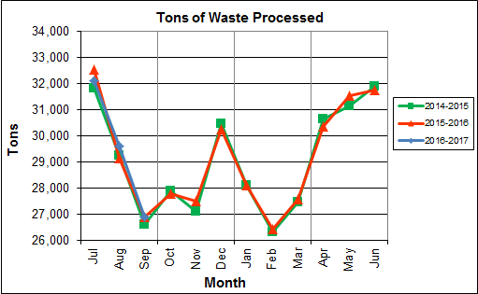

Chart 1 illustrates that Q1FY17 waste processed was ever so slightly higher (0.1%) than the corresponding quarter, Q1FY16.

CAAI reported that 473 tipping floor/MSW internal inspections were conducted during the quarter and six (6) notices of violation (NOVs) were issued to haulers for the following issues:

* July 2016 – Three (3) NOVs were issued for:
  + Two (2) NOVs for concrete in the load
  + One (1) NOV for sheet rock in the load
* August 2016 – One (1) NOV was issued for:
  + Excessive metal in the load
* September 2016 – Two (2) NOVs were issued for:
  + Dumping without a ticket

Chart 2: Tons of Ash Produced per Ton of Waste Processed

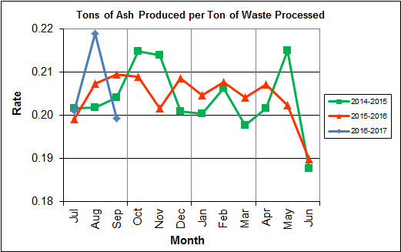

Chart 2 illustrates that the average ash production rate in Q1FY17 was higher (0.2%) at 20.7% of processed waste, compared to the corresponding quarter in FY16 when the rate was 20.5%. Ash production remains in the 20.0% to 21.0% range, as a result of the installation of the “semi-dry” ash discharger spray system in May 2012, and represents less moisture in the ash residue shipped to disposal.

Chart 3: Ferrous Recovery Rate

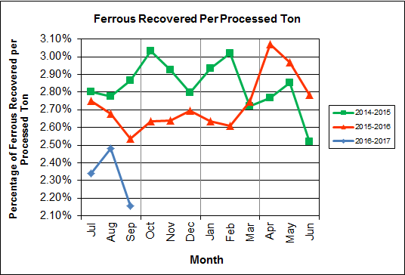

Chart 3 depicts the monthly ferrous metal recovery rate as a percentage of processed MSW tonnage. In Q1FY17, 2,066 tons of ferrous metals were recovered, which is 12.4% lower than the corresponding quarter in FY16 and equivalent to 2.3% of processed waste. CAAI indicated that it replaced an end section of the vibrating pan during Q3FY16 which was worn due to wear from material getting caught between the pan and magnet. The positive impacts of the end section pan replacement were noticed in Q4FY16, but have since declined significantly in Q1FY17. CAAI attributes the significant decline to an increase in recycling rates resulting in less metal in the MSW. CAAI also indicated that it replaced the last 8” of the main vibrating ash pan at the magnet in order to address declining ferrous metal recovery.

Chart 4: Steam Production

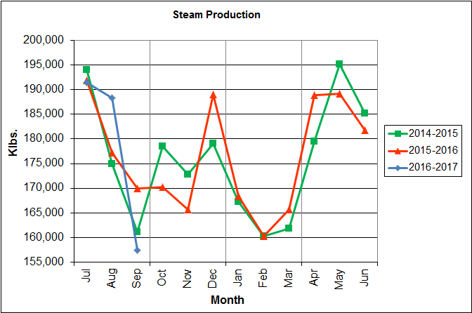

In Chart 4, the total steam production for Q1FY17 was 537,123 klbs., and lower (0.4%) than the corresponding quarter in FY16. The decrease in steam generation is attributable to CAAI throttling back the boilers to stay below the steam production limit each month.

Chart 5: 12-Month Rolling Steam Production

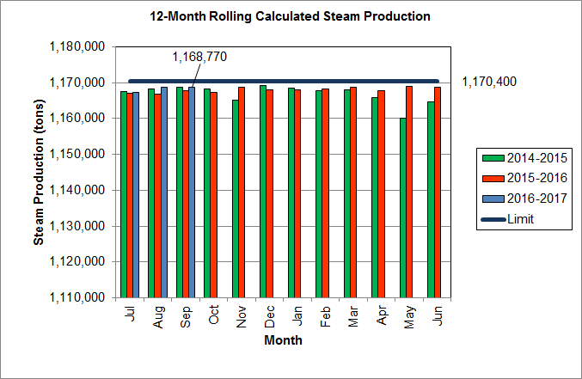

Chart 5 depicts the 12-month rolling steam production total for the period ending in September 2016. According to the Title V permit, the annual steam production for the Facility shall not exceed 1,170,400 tons on the basis of an average value of 3.34 lbs of steam per lb of MSW processed, calculated monthly as the sum of each consecutive 12 month period. The Facility was in compliance with the 12-month rolling steam production total every month in Q1FY17. The 12-month rolling total for steam production ending in September 2016 was 1,168,770 tons which is 99.9% of the limit. Chart 5 clearly shows that Facility throughput, and in turn, steam and electricity production are being throttled to stay ever so slightly below the steam production limit nearly every month.

Chart 6: Steam Production Rate

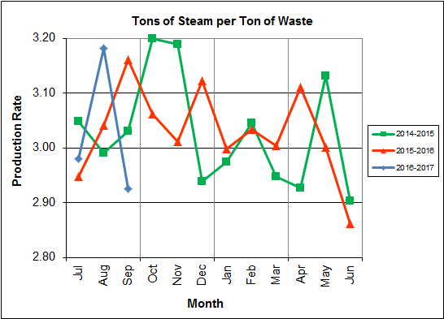

In Chart 6, the conversion of raw waste tonnages into “reference tons” is another way of analyzing steam production, and helps to determine whether changes are related to boiler performance or to fuel issues. “Reference tons” are adjusted to account for the calculated average fuel heating value, so that lower Btu fuel raw tonnages are adjusted upwards and vice versa. In Q1FY17, this metric tracked lower (2.3%) at 2.8 tonssteam/tonref, compared to the corresponding quarter in FY16. This trend should continue to be monitored to determine if it is indicative of poorer boiler performance, an aberration during scheduled outage periods, or some other currently unexplained cause.

Chart 7: Calculated Waste Heating Value

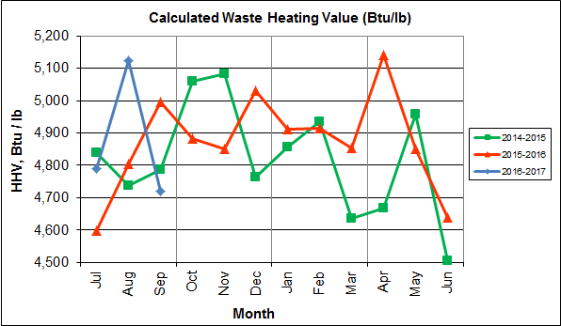

Chart 7 illustrates that Q1FY17 calculated average waste heating value was higher (1.6%) at 4,878 Btu/lb than the corresponding quarter Q1FY16, which averaged 4,800 Btu/lb.

Table 2: Quarterly Performance Summaries

|  |  |  |  |  |  |  |  |  |
| --- | --- | --- | --- | --- | --- | --- | --- | --- |
| Month | | Waste Processed (tons) | Waste Diverted  (tons) | Ash Shipped  (tons) | Special Handling (Supplemental)  (tons) | Ferrous Recovered  (tons) | Steam Produced (klbs) | Net Electrical Generation  (MWhr) |
| **Q1FY15** | **Quarterly Totals** | **87,659** | **0** | **17,751** | **745** | **2,465** | **530,025** | **36,806** |
| July -14 | 31,818 | 0 | 6,417 | 141 | 891 | 193,977 | 13,779 |
| August -14 | 29,247 | 0 | 5,904 | 275 | 812 | 174,887 | 12,018 |
| September -14 | 26,594 | 0 | 5,430 | 329 | 762 | 161,161 | 11,009 |
| **Q1FY16** | **Quarterly Totals** | **88,572** | **0** | **18,162** | **1,874** | **2,357** | **539,103** | **37,062** |
| July -15 | 32,537 | 0 | 6,482 | 676 | 895 | 191,850 | 13,358 |
| August -15 | 29,150 | 0 | 6,047 | 427 | 780 | 177,256 | 12,048 |
| September -15 | 26,885 | 0 | 5,633 | 771 | 682 | 169,997 | 11,656 |
| **Q1FY17** | **Quarterly Totals** | **88,622** | **0** | **18,307** | **1,880** | **2,066** | **537,123** | **37,367** |
| July -16 | 32,121 | 0 | 6,459 | 504 | 752 | 191,425 | 13,363 |
| August -16 | 29,593 | 0 | 6,482 | 642 | 734 | 188,295 | 13,092 |
| September -16 | 26,908 | 0 | 5,366 | 734 | 580 | 157,403 | 10,912 |
| **FY17 YTD Totals** | | **88,622** | **0** | **18,307** | **1,880** | **2,066** | **537,123** | **37,367** |
| **FY16 Totals** | | **349,881** | **0** | **71,401** | **8,567** | **9,571** | **2,118,125** | **148,529** |
| **FY15 Totals** | | **348,686** | **0** | **71,019** | **5,413** | **9,864** | **2,109,442** | **145,085** |

Table 2 presents the production data provided to HDR by CAAI for Q1FY17 on both a monthly and quarterly basis. For purposes of comparison, data for Q1FY15 and Q1FY16 are also shown, as well as FY15, FY16 and FY17 YTD totals.

In comparing quarterly totals, the data shows:

* Slightly more waste was processed in Q1FY17 than Q1FY16 and Q1FY15
* Less steam was generated in Q1FY17 than Q1FY16 and more than Q1FY15
* More electricity was generated in Q1FY17 than Q1FY16 and Q1FY15
* More supplemental waste was received in Q1FY17 than Q1FY16 and significantly more than in Q1FY15.

Please note that the total steam generation figures presented in Table 2 do not correlate with the annual steam production limit from the Facility Permit; such limits apply on a 12-month rolling average monthly basis, and not a fiscal year basis. It is also worth noting that the quantity of waste processed during Q1FY17 continues to be limited by the steam production permit restrictions (refer to Chart 5).

Table 3: Waste Delivery Classification

|  |  |  |  |  |  |  |  |  |  |  |  |  |  |  |  |
| --- | --- | --- | --- | --- | --- | --- | --- | --- | --- | --- | --- | --- | --- | --- | --- |
|  |  | **Jul** | **Aug** | **Sep** | **Oct** | **Nov** | **Dec** | **Jan** | **Feb** | **Mar** | **Apr** | **May** | **Jun** | **Totals** | **% of Total** |
| **FY13** | **Jurisdiction Waste** | 19,413 | 18,357 | 16,632 | 17,625 | 18,838 | 16,195 | **-** | **-** | **-** | **-** | **-** | **-** | 107,058 | 30.76% |
| **Spot Waste tons** | 10,516 | 11,326 | 10,610 | 10,317 | 9,330 | 9,558 | **-** | **-** | **-** | **-** | **-** | **-** | 61,656 | 17.72% |
| **City Waste** | **-** | **-** | **-** | **-** | **-** | **-** | 1,683(1) | 1,287 | 1,444 | 2,382 | 2,286 | 1,919 | 11,000 | 3.16% |
| **County Waste** | **-** | **-** | **-** | **-** | **-** | **-** | 2,442(1) | 2,100 | 2,372 | 3,381 | 3,932 | 3,309 | 17,536 | 5.04% |
| **Municipal Solid Waste** | **-** | **-** | **-** | **-** | **-** | **-** | 25,019(1) | 23,637 | 21,661 | 27,066 | 25,794 | 24,930 | 148,107 | 42.56% |
| **Supplemental Waste** | 151 | 11 | 80 | 25 | 234 | 405 | 363 | 365 | 76 | 403 | 281 | 271 | 2,665 | 0.77% |
| **MSW Totals** | **29,928** | **29,683** | **27,241** | **27,942** | **28,167** | **25,753** | **29,507** | **27,388** | **25,552** | **33,231** | **32,293** | **30,429** | **348,022** | **100.00%** |
|  |  | **Jul** | **Aug** | **Sep** | **Oct** | **Nov** | **Dec** | **Jan** | **Feb** | **Mar** | **Apr** | **May** | **Jun** | **Totals** | **% of Total** |
| **FY14** | **City Waste** | 2,065 | 1,693 | 1,702 | 1,924 | 1,566 | 1,780 | 1,529 | 1,231 | 1,556 | 2,256 | 2,203 | 1,883 | 21,389 | 6.11% |
| **County Waste** | 3,459 | 3,079 | 2,784 | 3,091 | 2,707 | 2,802 | 2,568 | 1,957 | 2,272 | 3,326 | 3,987 | 3,387 | 35,419 | 10.12% |
| **Municipal Solid Waste** | 26,167 | 23,604 | 22,034 | 23,354 | 21,879 | 25,531 | 23,869 | 22,523 | 23,198 | 25,414 | 27,206 | 24,812 | 289,590 | 82.75% |
| **Supplemental Waste** | 546 | 676 | 248 | 410 | 188 | 268 | 275 | 192 | 231 | 253 | 151 | 110 | 3,548 | 1.01% |
| **MSW Totals** | **32,237** | **29,053** | **26,768** | **28,779** | **26,340** | **30,380** | **28,241** | **25,903** | **27,256** | **31,249** | **33,546** | **30,193** | **349,946** | **100.00%** |
|  |  | **Jul** | **Aug** | **Sep** | **Oct** | **Nov** | **Dec** | **Jan** | **Feb** | **Mar** | **Apr** | **May** | **Jun** | **Totals** | **% of Total** |
| **FY15** | **City Waste** | 1,814 | 1,497 | 1,699 | 1,737 | 1,518 | 1,770 | 1,411 | 1,209 | 1,648 | 2,155 | 2,059 | 2,045 | 20,562 | 5.91% |
| **County Waste** | 3,297 | 2,868 | 2,973 | 3,095 | 2,508 | 2,852 | 2,358 | 1,833 | 2,411 | 3,269 | 3,652 | 3,572 | 34,687 | 9.96% |
| **Municipal Solid Waste** | 26,661 | 24,466 | 21,887 | 21,241 | 21,678 | 27,906 | 24,611 | 20,915 | 24,094 | 25,189 | 23,126 | 25,667 | 287,442 | 82.57% |
| **Supplemental Waste** | 141 | 275 | 329 | 521 | 764 | 529 | 389 | 351 | 272 | 613 | 531 | 698 | 5,413 | 1.55% |
| **MSW Totals** | **31,913** | **29,106** | **26,888** | **26,595** | **26,468** | **33,057** | **28,769** | **24,308** | **28,424** | **31,225** | **29,369** | **31,982** | **348,105** | **100.00%** |
|  |  | **Jul** | **Aug** | **Sep** | **Oct** | **Nov** | **Dec** | **Jan** | **Feb** | **Mar** | **Apr** | **May** | **Jun** | **Totals** | **% of Total** |
| **FY16** | **City Waste** | 1,960 | 1,563 | 1,723 | 1,645 | 1,685 | 1,872 | 1,147 | 1,619 | 1,811 | 2,024 | 1,950 | 2,220 | 21,219 | 6.03% |
| **County Waste** | 3,627 | 2,880 | 2,832 | 2,869 | 2,682 | 2,891 | 2,025 | 2,389 | 2,694 | 2,406 | 2,508 | 2,661 | 32,465 | 9.22% |
| **Municipal Solid Waste** | 27,933 | 22,999 | 22,552 | 22,850 | 20,679 | 26,138 | 22,632 | 22,781 | 22,935 | 24,388 | 26,561 | 27,355 | 289,801 | 82.32% |
| **Supplemental Waste** | 676 | 427 | 771 | 684 | 676 | 787 | 642 | 850 | 792 | 996 | 605 | 661 | 8,565 | 2.43% |
| **MSW Totals** | **34,196** | **27,869** | **27,878** | **28,047** | **25,722** | **31,687** | **26,446** | **27,639** | **28,232** | **29,814** | **31,623** | **32,896** | **352,049** | **100.00%** |
|  |  | **Jul** | **Aug** | **Sep** | **Oct** | **Nov** | **Dec** | **Jan** | **Feb** | **Mar** | **Apr** | **May** | **Jun** | **Totals** | **% of Total** |
| **FY17** | **City Waste** | 1,678 | 1,836 | 1,668 |  |  |  |  |  |  |  |  |  | 5,181 | 5.83% |
| **County Waste** | 2,386 | 2,469 | 2,370 |  |  |  |  |  |  |  |  |  | 7,225 | 8.13% |
| **Municipal Solid Waste** | 24,862 | 26,976 | 22,760 |  |  |  |  |  |  |  |  |  | 74,598 | 83.93% |
| **Supplemental Waste** | 504 | 642 | 734 |  |  |  |  |  |  |  |  |  | 1,880 | 2.12% |
| **MSW Totals** | **29,430** | **31,922** | **27,532** |  |  |  |  |  |  |  |  |  | **88,885** | **100.00%** |
| **Note (1): Beginning January 2013, the method in which waste was classified was modified as compared to prior periods due to change in contractual obligations and plant ownership** | | | | | | | | | | | | | | | |

Chart 8: Cumulative Total Waste Delivery

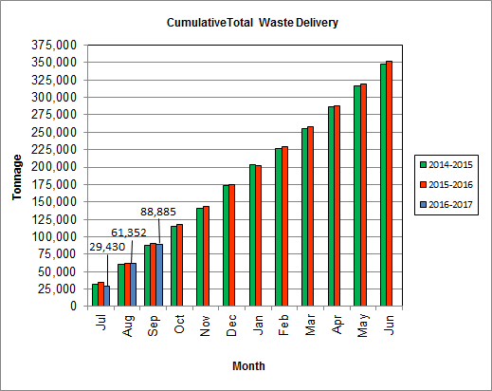

As depicted in Table 3 and Chart 8, for the quarter ending in September 2016; cumulative total waste delivery was 1.2% less compared to the same period in FY16.

Chart 9: Gross Electrical Generation

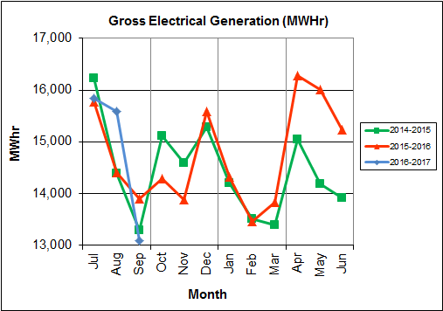

During Q1FY17, the Facility generated 44,524 MWhrs (gross) of electricity compared to Q1FY16 generation of 44,083 MWhrs (gross), a 1.0% increase. The Facility generated more electricity (gross) in Q1FY17 as compared to Q1FY16 despite lower steam generation, and more downtime (102.3 additional hours) experienced by the turbine generators. Note that the sharp spikes depicted in Chart Nos. 10 through 14 for the months of May and June 2015 are a result of significant downtime (424.7 hours) experienced by Turbine Generator No. 1 to repair an exciter failure.

Chart 10: Gross Conversion Rate

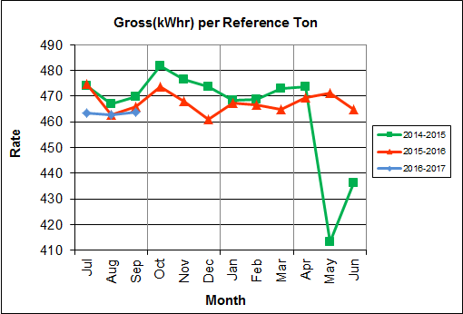

As shown in Chart 10, the average gross electrical generation per reference ton of refuse processed during Q1FY17 was 463 kWhr, which is 1.0% lower than the corresponding quarter in FY16, and is attributable to more downtime experienced by the turbine generators during the quarter when compared to the corresponding quarter in FY16. Since this calculated value uses reference or normalized tonnages of waste, it should cancel the effect of MSW heating value (Btu content) variability.

Chart 11: Net Conversion Rate

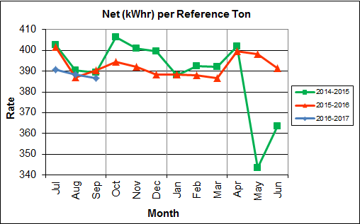

Chart 11 depicts the normalized net power (gross minus in-house usage) generation history. In Q1FY17, the average net electrical generation per reference ton was 389 kWhr, which is 1.1% lower than the corresponding quarter in FY16, and again, attributable to more downtime experienced by the Turbine Generators during the quarter, when compared to the corresponding quarter last fiscal year.

Chart 12: Net Conversion Rate

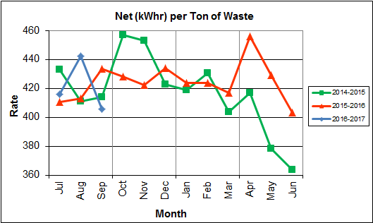

Chart 12 depicts the net power generation per processed ton. The net electrical generation per processed ton in Q1FY17 was 421 kWhr, which is 0.5% higher than the corresponding quarter in FY16, and attributable to higher (1.6%) calculated waste heating value, offset by more downtime experienced by the turbine generators when compared to the corresponding quarter last fiscal year.

Chart 13: Gross Turbine Generator Conversion Rate

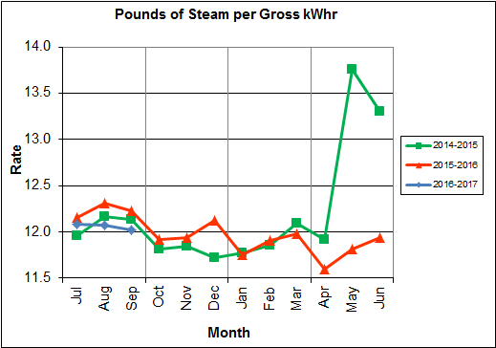

Charts 13 and 14 illustrate the quantities of steam required to generate one (1) kWhr of electricity, gross and net respectively. This measure is a turbine generator performance indicator, where lower steam rates indicate superior performance. For simplification, this calculated rate is based on the average for the two turbine generators. In Q1FY17 the average lbs of steam consumed per gross kWhr generated was 12.1, which is 1.4% lower (improved) than the corresponding quarter Q1FY16. A factor that negatively impacts this metric is Turbine Generator No. 2 continues to operate with its Stage 9 blades removed from the rotor. CAAI reported that during the Turbine Generator No. 2 overhaul in November 2013, some cracking was observed on the Stage 9 blades of the rotor, and the blading in that row was removed as a precautionary measure. CAAI originally indicated that a new set of blades would be manufactured and installed during a Turbine Generator No. 2 Outage in 2016, but advised in May 2015, that the implementation of the replacement blades installation would be delayed, and did not provide a date for repair. The average lbs of steam consumed per net kWhr was 14.4, which is 1.2% lower (improved) than the corresponding quarter in FY16. The average steam temperature during the quarter was 685.1° F, which is 1.0% higher than the average steam temperature of the corresponding quarter last fiscal year and 14.9° F lower than design temperature of 700o F.

Chart 14: Net Turbine Generator Conversion Rate

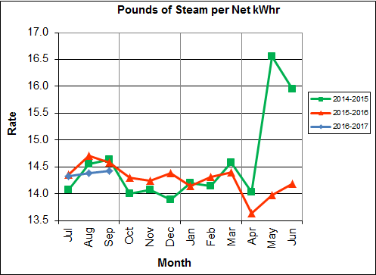

## Utility and Reagent Consumptions

Table 4: Facility Utility and Reagent Consumptions

|  |  |  |  |  |  |
| --- | --- | --- | --- | --- | --- |
| **Utility** | **Units** | **Q1FY17 Total** | **Q1FY16**  **Total** | **Q1FY17”Per Processed Ton” Consumption** | **Q1FY16”Per Processed Ton” Consumption** |
| **Purchased Power** | MWhr | 5,598 | 5,477 | 0.06 | 0.06 |
| **Fuel Oil** | Gal. | 21,430 | 10,510 | 0.24 | 0.12 |
| **Boiler Make-up** | Gal. | 1,641,000 | 2,066,000 | 18.52 | 23.33 |
| **Cooling Tower Make-up** | Gal. | 45,019,026 | 42,240,267 | 507.99 | 476.90 |
| **Pebble Lime** | Lbs. | 1,254,000 | 1,334,000 | 14.15 | 15.06 |
| **Ammonia** | Lbs. | 170,000 | 166,000 | 1.92 | 1.87 |
| **Carbon** | Lbs. | 92,000 | 102,000 | 1.04 | 1.15 |
| **Dolomitic Lime** | Lbs. | 170,000 | 202,800 | 1.92 | 2.29 |

Fuel oil usage during the quarter represents approximately 0.37% of the total heat input to the boilers, which compares favorably with industry averages, and slightly higher than the percentage of heat input in Q1FY16 which was 0.18%. Fuel oil is used to stabilize combustion of wet fuel, as well as during start-up and shut-down of the boilers for maintenance. Boiler makeup water usage during the quarter represents 2.5% of steam flow, which is lower than the boiler makeup in Q1FY16 which was 3.2%, and is acceptable. Pebble lime usage, at 1,254,000 lbs. is lower (6.0%) than the corresponding quarter last year, and the quarterly consumption rate of 14.2 lbs/ton is below historical levels (16-18 lbs/ton).

In comparing Q1FY17 to Q1FY16 on a per processed ton consumption basis:

* the purchased power consumption rate was 2.2% higher
* the total fuel oil consumption rate was 103.8% higher
* the boiler make-up water consumption rate was 20.6% lower
* the cooling tower make-up water consumption rate was 6.5% higher
* the total pebble lime consumption rate was 6.1% lower
* the ammonia consumption rate was 2.4% higher
* the carbon consumption rate was 9.9% lower
* the total dolomitic lime consumption rate was 16.2% lower

CAAI reported that the significant decrease in dolomitic lime usage is a result of lowering feed rate in recent months based on pH levels (average in-house pH of 9.0 during Q1FY17).

## Safety & Environmental Training

The Facility experienced (1) OSHA recordable accident during the quarter. CAAI reported the incident occurred on September 19, 2016 and was a result of an operator tripping over caution tape causing a broken leg. Prior to the incident, the Facility operated 247 days without an OSHA recordable accident. During the quarter, Safety and Environmental training was conducted with themes as follows:

**July 2016**

* Safety:
  + Hot Work
  + Heat Stress
  + Safety Committee
  + Welding & Cutting
* Environmental:
  + Profiled Waste
  + Unauthorized Waste
  + Stack Testing

**August 2016**

* Safety:
  + Lock-Out-Tag-Out
  + Control of Hazardous Energy
  + Crane Boarding
  + Hopper Safety Systems
  + Social Norms
* Environmental:
  + Unauthorized Waste Training
  + Ash Generation
  + Treatment and Testing
  + Fugitive Ash

**September 2016**

* Safety:
  + JOB Observations
  + Accident Prevention Program
  + Housekeeping
  + Disposal of Potentially Contaminated Debris
  + Medical Surveillance
* Environmental:
  + Water Balance
  + Conservation and Industrial Waste Water

# Facility Maintenance

Throughout the quarter, significant routine and preventative maintenance was performed. HDR considers that the Facility is implementing an effective maintenance regimen, and is performing routine and preventative maintenance, along with selected equipment replacements in a timely manner. CAAI monthly maintenance reports provide a detailed account of maintenance performed.

Beginning July 13, 2016 Boiler No. 1 experienced 24.1 hours of downtime for a scheduled cleaning outage. No significant outage maintenance items were highlighted by CAAI in the Monthly Report.

Beginning August 16, 2016 Boiler No. 3 experienced 25.0 hours of downtime for a scheduled cleaning outage. Some significant maintenance items completed during the outage are as follows:

* Repaired a crack on the north side of Boiler No. 3 Gen Bank Outlet Hopper
* Repair of No. 3 Mud Drum Blowdown Valve
* Repaired a leak on the Boiler No. 3 Feedchute Lower Water Jacket
* Change-out of faulty Programmable Logic Controller (PLC) on Boiler No. 3 Stoker Panel

Beginning September 17, 2016 Boiler No. 2 experienced 116.2 hours of downtime for scheduled maintenance. Some significant maintenance items completed during the outage are as follows:

* Change-out of grate bars Steps 1 through 8 on both runs
* Change-out of J-bars on both runs
* Replacement of the Sootblower upper root valve with a 900 lb. class valve
* Installation of a new hinged door on the Convection Pass Hopper
* Installation of an access door to help with ash discharger plugs by the rear entry door
* Repair of holes in the ash discharger and transition chute
* Change of oil in all the bag house fly ash conveyor gear boxes and rotary valves
* Repair holes in three (3) of the bag house hopper screw conveyor covers
* Replacement of elements on Sootblowers G9B No. 6 and G9B No. 29
* Removal and replacement of 37 tube shields in the superheater

In addition to the scheduled maintenance, CAAI reports that 929 preventative maintenance actions were completed during the quarter.

## Availability

Facility availabilities for Q1FY17 are shown in Table 5. According to CAAI reports, the average unit availabilities for Boiler Nos. 1, 2, and 3 for Q1FY17 were 97.7%, 94.6%, and 98.7%, respectively. The three-boiler average availability during the quarter was 97.0%, which is excellent.

During Q1FY17, the average availability for Turbine Generator Nos. 1 and 2 was 100.0%. The two-turbine generator average availability during the quarter was 100.0%, which is excellent.

Table 5: Quarterly Facility Unit Availabilities

|  |  |
| --- | --- |
| **Availability** | **Q1FY17 Average** |
| Boiler No. 1 | 97.7% |
| Boiler No. 2 | 94.6% |
| Boiler No. 3 | 98.7% |
| ***Avg.*** | ***97.0%*** |
| Turbine No. 1 | 100.0% |
| Turbine No. 2 | 100.0% |
| ***Avg.*** | ***100.0%*** |

## Downtime Summary

Table 6: Boiler Downtime – Q1FY17

|  |  |  |  |  |  |  |
| --- | --- | --- | --- | --- | --- | --- |
| **Boiler Number** | **Outage Begin Date** | **Outage End Date** | **Hours Unavailable** | | **Downtime**  **Classification** | **Reason Unavailable** |
| 1 | 7/13/16 | 7/14/16 | 24.1 | | Scheduled | Scheduled Boiler Cleaning Outage |
| 1 | 8/17/16 | 8/17/16 | 7.0 | | Unscheduled | MCC Switchgear Replacement |
| 3 | 8/15/16 | 8/15/16 | 4.7 | | Unscheduled | Programmable Logic Controller Repairs & Forced Draft Fan Electrical Repairs |
| 3 | 8/16/16 | 8/17/16 | 25.0 | | Scheduled | Scheduled Boiler Cleaning Outage |
| 1 | 9/2/16 | 9/2/16 | 20.9 | | Unscheduled | Tube Leak Repair |
| 1 | 9/18/16 | 9/19/16 | 22.4 | | Standby | 480V Switchgear Replacement and Process Limitations Preventative Measure |
| 2 | 9/17/16 | 9/22/16 | 116.2 | | Scheduled | Scheduled Boiler Outage |
| 3 | 9/17/16 | 9/19/16 | 56.5 | | Standby | 480V Switchgear Replacement and Process Limitations Preventative Measure |
| 2 | 9/22/16 | 9/22/16 | 9.5 | | Standby | Preventative measure taken to avoid exceeding 350,000 ton rolling 12-month process limit |
| **Total Unscheduled Downtime** | | | | **32.6 Hours** | | |
| **Total Scheduled Downtime** | | | | **165.3 Hours** | | |
| **Total Standby Downtime** | | | | **88.4 Hours** | | |
| **Total Downtime** | | | | **286.3 Hours** | | |

Table 7: Turbine Generator Downtime – Q1FY17

|  |  |  |  |  |  |  |
| --- | --- | --- | --- | --- | --- | --- |
| **Turbine Generator Number** | **Outage Begin Date** | **Outage End Date** | **Hours Unavailable** | | **Downtime**  **Classification** | **Reason Unavailable** |
| 1 | 8/17/16 | 8/17/16 | 10.0 | | Standby | MCC Switchgear Replacement |
| 1 | 9/18/16 | 9/19/16 | 23.8 | | Standby | 480V Switchgear Replacement |
| 2 | 9/17/16 | 9/22/16 | 143.5 | | Standby | Boiler No. 2 Outage and Process Limitations Preventative Measure |
| **Total Unscheduled Downtime** | | | | **0.0 Hours** | | |
| **Total Scheduled Downtime** | | | | **0.0 Hours** | | |
| **Total Standby Downtime** | | | | **177.3 Hours** | | |
| **Total Downtime** | | | | **177.3 Hours** | | |

## Facility Housekeeping

CAAI is performing Facility housekeeping and maintaining plant cleanliness in accordance with acceptable industry practices. A site inspection was conducted in August 2016. At the time of the inspection, new deficiencies were recorded and prior deficiencies were given a status update. Photos of interest from the inspection are depicted in Appendix B. The Facility housekeeping ratings from the August 2016 inspection are presented in Table 8.

Table 8: Facility Housekeeping Ratings – August 2016

| **Facility Area** | **Acceptable** | **Needs Improvement** | **Unacceptable** |
| --- | --- | --- | --- |
| **Tipping Floor** | √ |  |  |
| **Citizen’s Drop-off Area** | √ |  |  |
| **Tipping Floor Truck Exit** | √ |  |  |
| **Front Parking Lot** | √ |  |  |
| **Rear Parking Lot** | √ |  |  |
| **Boiler House Pump Room** | √ |  |  |
| **Lime Slurry Pump Room** | √ |  |  |
| **Switchgear Area** | √ |  |  |
| **Ash Load-out Area** | √ |  |  |
| **Vibrating Conveyor Area** | √ |  |  |
| **Ash Discharger Area** | √ |  |  |
| **Cooling Tower Area** | √ |  |  |
| **Truck Scale Area** | √ |  |  |
| **SDA/FF Conveyor Area** | √ |  |  |
| **SDA Penthouses** | √ |  |  |
| **Lime Preparation Area** | √ |  |  |
| **Boiler Drum Levels** | √ |  |  |
| **Turbine Room** | √ |  |  |
| **Electrical Room** | √ |  |  |

# Environmental

The air pollution control equipment maintained emission concentrations well within the established regulations. Average Continuous Emission Monitoring System (CEMS) data collected for each monthly period during Q1FY17 are summarized in Appendix A. No permit deviations were reported by the Facility during Q1FY17.

On August 8, 2014, CAAI sent a letter to the Virginia Department of Environmental Quality (VADEQ) requesting relief from the steam permit limit requirements in the Facility’s Title V and PSD permits. These requested changes relate to the permit values established for the calculated steam-to-waste ratio, which has resulted in a reduction of MSW throughput. In recent discussions, CAAI indicated that it is re-evaluating options to the proposed permit changes, and will provide further updates on this issue.

## Nitrogen Oxide Emissions

During Q1FY17, the monthly emission concentrations of nitrogen oxides (NOx) averaged 164.3 ppmdv, 161.7 ppmdv and 162.3 ppmdv for Boiler Nos. 1, 2, and 3, respectively. CAAI continues to operate the units at the lower (160 ppmdv) set-points, except immediately following a scheduled outage and associated boiler cleaning.

## Sulfur Dioxide Emissions

During Q1FY17 the monthly emission concentration of stack sulfur dioxide (SO2) averaged 2.0 ppmdv, 0.7 ppmdv, and 1.0 ppmdv for Boiler Nos. 1, 2, and 3, respectively. All of these stack SO2 concentrations are significantly below the 40 CFR Subpart Cb requirement of 29 ppmdv @ 7% O2.

## Carbon Monoxide Emissions

During Q1FY17, the average CO emission concentrations on Boiler Nos. 1, 2, and 3 were 31.3 ppmdv, 34.0 ppmdv, and 34.7 ppmdv, respectively, and all are well within permit limits (100 ppmdv, hourly average). However, as reported by HDR during the May 2016 FMG Meeting, CO averages have been trending higher over the past six (6) months on all three boilers, and CAAI has been requested to investigate and mitigate this uptrend. While not a permit issue, it is indicative of poorer boiler performance and combustion efficiency.

## Opacity

During Q1FY17, the average opacity for Boiler Nos. 1, 2, and 3 was 0.9%, 0.4%, and 0.0% respectively. All of these averages are significantly below the 10% (6-minute) average permit limit.

## Daily Emissions Data

Appendix A, Tables 10, 11, and 12 tabulate the monthly average, maximum, and minimum emissions data for each unit during Q1FY17. Excursions, if any, would appear in bold print. It should be noted that these tabulations of monthly averages, reported here for informational purposes, are based on tabulations of daily averages. These averages do not correlate with official reports to the regulatory agencies because of differences in averaging times and other technical differences required by agency report formats.

## Ash System Compliance

The dolomitic lime feed rate is adjusted periodically in order to maintain a desired ash pH level in the range of 8.0 to 11.0. Since initial startup, the feed rate has varied from between 1 to 9 lbs per ton each month. Ash Toxicity (TCLP) tests were performed for field samples collected over a seven (7) day period in August 2016, and results indicated that the average pH during testing was 8.4. Results from the TCLP testing conducted in August 2016 are depicted in Table 9 and Chart 15 below.

Table 9: Comparison of Statistical Results and Regulatory Thresholds for Metal Analytes

|  |  |  |  |  |  |
| --- | --- | --- | --- | --- | --- |
| **Metals** | **90% Upper Confidence**  **(August 2016** | **90% Upper Confidence**  **(October 2015)** | **Regulatory Threshold (mg/L)** | **% of Threshold (August 2016)** | **% of Threshold (October 2015)** |
| **Arsenic** | 0.250 | 0.250 | 5.0 | 5.00% | 5.00% |
| **Barium** | 0.805 | 0.888 | 100.0 | 0.81% | 0.89% |
| **Cadmium** | 0.154 | 0.058 | 1.0 | 15.40% | 5.80% |
| **Chromium** | 0.250 | 0.250 | 5.0 | 5.00% | 5.00% |
| **Lead** | 0.250 | 0.250 | 5.0 | 5.00% | 5.00% |
| **Mercury** | 0.00025 | 0.0002 | 0.2 | 0.13% | 0.10% |
| **Selenium** | 0.050 | 0.050 | 1.0 | 5.00% | 5.00% |
| **Silver** | 0.250 | 0.250 | 5.0 | 5.00% | 5.00% |

Chart 15: Ash Toxicity Characteristic Leaching Procedure (TCLP) Results

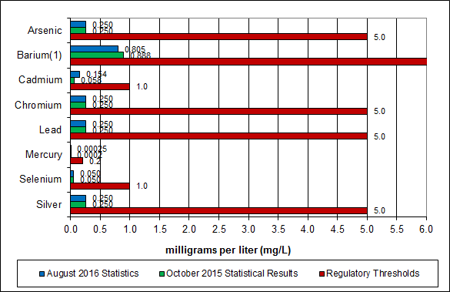

**Note: The regulatory threshold for Barium is 100 mg/L**

CAAI also samples ash monthly in-house, and documents pH reading to adjust dolomitic lime feed rate. The results for the ash pH tests are found below in Chart 16 where each quarter is represented by the average of the respective monthly readings. During Q1FY17, the average ash pH for in-house tests was 9.0.

Chart 16: Quarterly Ash Test Results

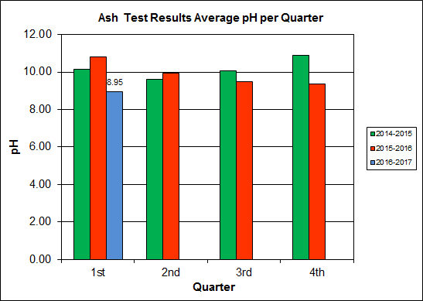

APPENDIX A  
FACILITY CEMS DATA

Table 10: Unit #1 Monthly Summary for Reportable Emissions Data

|  |  |  |  |  |  |  |  |  |  |  |
| --- | --- | --- | --- | --- | --- | --- | --- | --- | --- | --- |
| **Group#-Channel#** | | **G8-C35** | **G8-C28** | **G8-C8** | **G8-C4** | **G8-C12** | **G8-C34** | **G8-C37** | **G8-C40** | **G8-C39** |
| **Long Descrip.** | | **U-1 Steam** | **U-1 Econ** | **U-1 Stack** | **U-1 Stack** | **U-1 Stack** | **U-1 Opaci** | **U-1 FF In** | **U-1 Carbo** | **U-1 Lime** |
| **Short Descrip.** | | **SteamFl** | **SO2ec** | **SO2sc** | **COsc** | **NOxsc** | **Opacity** | **FF InTemp** | **CarbInj** | **LimeFlow** |
| **Units** | | **K#/Hr** | **ppmc** | **ppm** | **ppmc** | **ppmc** | **%** | **deg F** | **#/hr** | **gpm** |
| **Range** | | **0-100** | **0-2000** | **0-500** | **0-4000** | **0-1000** | **0-100** | **100-500** | **0-50** | **0-20** |
| Jul-16 | AVG | 83.7 | 37.0 | 3.0 | 31.0 | 171.0 | 1.1 | 299.0 | 15.9 | 3.0 |
| Max | 86.6 | 69.0 | 5.0 | 40.0 | 188.0 | 1.8 | 301.0 | 18.3 | 3.3 |
| Min | 78.4 | 14.0 | 0.0 | 22.0 | 155.0 | 0.7 | 299.0 | 15.3 | 2.8 |
| Aug-16 | AVG | 85.6 | 37.0 | 2.0 | 35.0 | 160.0 | 0.8 | 300.0 | 15.3 | 3.1 |
| Max | 88.4 | 55.0 | 7.0 | 46.0 | 162.0 | 1.4 | 302.0 | 16.1 | 3.4 |
| Min | 82.8 | 23.0 | 0.0 | 21.0 | 159.0 | 0.5 | 297.0 | 15.1 | 3.0 |
| Sep-16 | AVG | 80.6 | 27.0 | 1.0 | 28.0 | 162.0 | 0.8 | 300.0 | 15.4 | 3.0 |
| Max | 85.6 | 44.0 | 5.0 | 35.0 | 167.0 | 1.5 | 301.0 | 15.7 | 5.0 |
| Min | 70.9 | 14.0 | 0.0 | 18.0 | 147.0 | 0.0 | 297.0 | 15.2 | 2.5 |
| **Quarter Average** | | 83.3 | 33.7 | 2.0 | 31.3 | 164.3 | 0.9 | 299.7 | 15.5 | 3.0 |
| **Quarter Max Value** | | 88.4 | 69.0 | 7.0 | 46.0 | 188.0 | 1.8 | 302.0 | 18.3 | 5.0 |
| **Quarter Min Value** | | 70.9 | 14.0 | 0.0 | 18.0 | 147.0 | 0.0 | 297.0 | 15.1 | 2.5 |
| **Limits:** | | 98 | NA | 29 | 100 | 205 | 10 | 333 | 16(a) |  |

(a) Carbon flow limit is a minimum value

* Note: The data reported herein represent 24 hour average data for all parameters. Emissions excursions that are measured on shorter time intervals (i.e., 4-hour block averages for CO) do not correlate with the 24 hour average data reported above.

Table 11: Unit #2 Monthly Summary for Reportable Emissions Data

|  |  |  |  |  |  |  |  |  |  |  |
| --- | --- | --- | --- | --- | --- | --- | --- | --- | --- | --- |
| **Group#-Channel#** | | **G8-C35** | **G8-C28** | **G8-C8** | **G8-C4** | **G8-C12** | **G8-C34** | **G8-C37** | **G8-C40** | **G8-C39** |
| **Long Descrip.** | | **U-2 Steam** | **U-2 Econ** | **U-2 Stack** | **U-2 Stack** | **U-2 Stack** | **U-2 Opaci** | **U-2 FF In** | **U-2 Carbo** | **U-2 Lime** |
| **Short Descrip.** | | **SteamFl** | **SO2ec** | **SO2sc** | **COsc** | **NOxsc** | **Opacity** | **FF InTemp** | **CarbInj** | **LimeFlow** |
| **Units** | | **K#/Hr** | **ppmc** | **ppm** | **ppmc** | **ppmc** | **%** | **deg F** | **#/hr** | **gpm** |
| **Range** | | **0-100** | **0-2000** | **0-500** | **0-4000** | **0-1000** | **0-100** | **100-500** | **0-50** | **0-20** |
| Jul-16 | AVG | 87.3 | 48.0 | 0.0 | 35.0 | 161.0 | 0.1 | 300.0 | 16.0 | 3.1 |
| Max | 89.6 | 77.0 | 2.0 | 44.0 | 164.0 | 0.4 | 300.0 | 18.5 | 3.4 |
| Min | 85.7 | 25.0 | 0.0 | 24.0 | 158.0 | 0.0 | 299.0 | 15.4 | 2.7 |
| Aug-16 | AVG | 85.2 | 35.0 | 1.0 | 37.0 | 159.0 | 0.4 | 299.0 | 15.4 | 3.2 |
| Max | 87.7 | 53.0 | 2.0 | 49.0 | 179.0 | 1.4 | 300.0 | 18.4 | 3.4 |
| Min | 82.1 | 18.0 | 0.0 | 26.0 | 157.0 | 0.0 | 297.0 | 15.1 | 2.9 |
| Sep-16 | AVG | 81.7 | 39.0 | 1.0 | 30.0 | 165.0 | 0.8 | 300.0 | 15.3 | 3.2 |
| Max | 88.4 | 69.0 | 3.0 | 42.0 | 177.0 | 1.4 | 300.0 | 15.7 | 3.4 |
| Min | 70.8 | 19.0 | 0.0 | 14.0 | 156.0 | 0.0 | 299.0 | 15.2 | 2.9 |
| **Quarter Average** | | 84.7 | 40.7 | 0.7 | 34.0 | 161.7 | 0.4 | 299.7 | 15.6 | 3.2 |
| **Quarter Max Value** | | 89.6 | 77.0 | 3.0 | 49.0 | 179.0 | 1.4 | 300.0 | 18.5 | 3.4 |
| **Quarter Min Value** | | 70.8 | 18.0 | 0.0 | 14.0 | 156.0 | 0.0 | 297.0 | 15.1 | 2.7 |
| **Limits:** | | 96 | NA | 29 | 100 | 205 | 10 | 330 | 16(a) |  |

(a) Carbon flow limit is a minimum value

* Note: The data reported herein represent 24 hour average data for all parameters. Emissions excursions that are measured on shorter time intervals (i.e., 4-hour block averages for CO) do not correlate with the 24 hour average data reported above.

Table 12: Unit #3 Monthly Summary for Reportable Emissions Data

|  |  |  |  |  |  |  |  |  |  |  |
| --- | --- | --- | --- | --- | --- | --- | --- | --- | --- | --- |
| **Group#-Channel#** | | **G8-C35** | **G8-C28** | **G8-C8** | **G8-C4** | **G8-C12** | **G8-C34** | **G8-C37** | **G8-C40** | **G8-C39** |
| **Long Descrip.** | | **U-3 Steam** | **U-3 Econ** | **U-3 Stack** | **U-3 Stack** | **U-3 Stack** | **U-3 Opaci** | **U-3 FF In** | **U-3 Carbo** | **U-3 Lime** |
| **Short Descrip.** | | **SteamFl** | **SO2ec** | **SO2sc** | **COsc** | **NOxsc** | **Opacity** | **FF InTemp** | **CarbInj** | **LimeFlow** |
| **Units** | | **K#/Hr** | **ppmc** | **ppm** | **ppmc** | **ppmc** | **%** | **deg F** | **#/hr** | **gpm** |
| **Range** | | **0-100** | **0-2000** | **0-500** | **0-4000** | **0-1000** | **0-100** | **100-500** | **0-50** | **0-20** |
| Jul-16 | AVG | 88.1 | 28.0 | 0.0 | 40.0 | 161.0 | 0.1 | 298.0 | 15.6 | 3.1 |
| Max | 91.1 | 46.0 | 4.0 | 53.0 | 162.0 | 0.3 | 303.0 | 18.5 | 3.8 |
| Min | 86.0 | 15.0 | 0.0 | 29.0 | 160.0 | 0.0 | 292.0 | 15.2 | 2.8 |
| Aug-16 | AVG | 86.0 | 38.0 | 1.0 | 37.0 | 167.0 | 0.0 | 298.0 | 15.3 | 3.3 |
| Max | 89.4 | 107.0 | 9.0 | 54.0 | 179.0 | 0.1 | 300.0 | 16.4 | 4.1 |
| Min | 72.7 | 10.0 | 0.0 | 23.0 | 147.0 | 0.0 | 293.0 | 15.0 | 3.1 |
| Sep-16 | AVG | 81.5 | 46.0 | 2.0 | 27.0 | 159.0 | 0.0 | 295.0 | 15.4 | 3.1 |
| Max | 89.2 | 84.0 | 5.0 | 37.0 | 161.0 | 0.0 | 298.0 | 15.9 | 3.8 |
| Min | 72.7 | 21.0 | 0.0 | 17.0 | 155.0 | 0.0 | 292.0 | 15.4 | 2.0 |
| **Quarter Average** | | 85.2 | 37.3 | 1.0 | 34.7 | 162.3 | 0.0 | 297.0 | 15.4 | 3.2 |
| **Quarter Max Value** | | 91.1 | 107.0 | 9.0 | 54.0 | 179.0 | 0.3 | 303.0 | 18.5 | 4.1 |
| **Quarter Min Value** | | 72.7 | 10.0 | 0.0 | 17.0 | 147.0 | 0.0 | 292.0 | 15.0 | 2.0 |
| **Limits:** | | 98 | NA | 29 | 100 | 205 | 10 | 327 | 16(a) |  |

(a) Carbon flow limit is a minimum value

* Note: The data reported herein represent 24 hour average data for all parameters. Emissions excursions that are measured on shorter time intervals (i.e., 4-hour block averages for CO) do not correlate with the 24 hour average data reported above.

APPENDIX B  
SITE PHOTOS – AUGUST 2016

|  |  |
| --- | --- |
| C:\Users\kperrin\Desktop\August 2016\P1020774.JPG  Figure 1: Safety Cage on Rotary Sootblower No. 27 detached and gears exposed – New Deficiency | C:\Users\kperrin\Desktop\August 2016\P1020776.JPG  Figure 2: Underside of grating deteriorated, upper elevations of all three economizers – New Deficiency |
| C:\Users\kperrin\Desktop\August 2016\P1020780.JPG  Figure 3: Hole in wall where forklift is typically parked, northwest corner of Main Vibrating Conveyor – New Deficiency | C:\Users\kperrin\Desktop\August 2016\P1020787.JPG  Figure 4: Emergency eye wash station is leaking, just off CEMS Enclosure – New Deficiency |
| C:\Users\kperrin\Desktop\August 2016\P1020756.JPG  Figure 5: Turbine Generator No. 2 | C:\Users\kperrin\Desktop\August 2016\P1020757.JPG  Figure 6: Ash Trailer Canopy |
| C:\Users\kperrin\Desktop\August 2016\P1020758.JPG  Figure 7: Citizen’s Drop-off Roll-off | C:\Users\kperrin\Desktop\August 2016\P1020759.JPG  Figure 8: Island removed at Facility roadway approaching scales |
| C:\Users\kperrin\Desktop\August 2016\P1020761.JPG  Figure 9: General Facility Photo – from across Eisenhower Avenue | C:\Users\kperrin\Desktop\August 2016\P1020763.JPG  Figure 10: General Facility Photo- from southwest of Facility |
| C:\Users\kperrin\Desktop\August 2016\P1020765.JPG  Figure 11: Facility Roadway – facing APC Area and Cooling Towers | **C:\Users\kperrin\Desktop\August 2016\P1020766.JPG**  Figure 12: Tipping Floor Entrance and Supplemental Waste Load-out Dock |
| C:\Users\kperrin\Desktop\August 2016\P1020770.JPG  Figure 13: Mixing Ash Samples for TCLP Ash Testing | C:\Users\kperrin\Desktop\August 2016\P1020793.JPG  Figure 14: Refuse Pit – photo from Tipping Floor Entrance |
| C:\Users\kperrin\Desktop\August 2016\P1020772.JPG  Figure 15: Refuse pit – photo from north side of Charging Floor | C:\Users\kperrin\Desktop\August 2016\P1020775.JPG  Figure 16: New decking around Economizers |
| C:\Users\kperrin\Desktop\August 2016\P1020778.JPG  Figure 17: New platforms installed around Induced Draft Fans | C:\Users\kperrin\Desktop\August 2016\P1020781.JPG  Figure 18: Main Vibrating Ash Conveyor |
| C:\Users\kperrin\Desktop\August 2016\P1020782.JPG  Figure 19: General Facility Photo – east of Ash Trailer Canopy | C:\Users\kperrin\Desktop\August 2016\P1020783.JPG  Figure 20: Ammonia Tank |
| C:\Users\kperrin\Desktop\August 2016\P1020785.JPG  Figure 21: Dolomitic Lime Silo – photo from east side of Cooling Towers | C:\Users\kperrin\Desktop\August 2016\P1020788.JPG  Figure 22: Front of Facility and Parking Area |
| C:\Users\kperrin\Desktop\August 2016\P1020790.JPG  Figure 23: General Facility Photo – from northeast corner of property | C:\Users\kperrin\Desktop\August 2016\P1020792.JPG  Figure 24: Scalehouse and Scales |